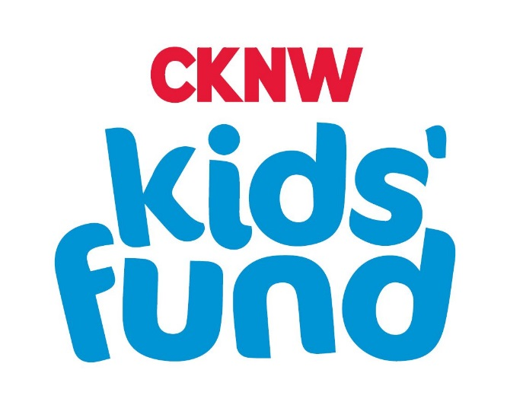

Request for Funding Organization

The Fund that Works for Challenged Children Twelve Months a Year

Grant Application Guidelines/Criteria

- Grants are to be used specifically for disadvantaged children.

- Special needs children are defined as birth to age 19, who are at risk physically, mentally, psychologically and socially.

- Applications are reviewed upon receipt from non-profit organizations and associations registered under the Societies Act of BC, operating for at least one year, in the province of BC, and where financial need can be demonstrated.

- Organizational funding is defined as grants to recognized agencies and organizations constituted for the benefit of children providing they meet our criteria and non-profit organizations, which provide services to children who have special needs. Grants can be made to purchase items or to pay for services that would otherwise not be available.

- Registered charities must include a registered charity business number.

- Funds are not to be utilized for salaries/operation or administrative costs.

- Decisions by the CKNW Kids’ Fund may be based, in part, on when an organization last received funding, and how much it received. The CKNW Kids’ Fund will only approve ONE application per year and will not provide multi-year funding.

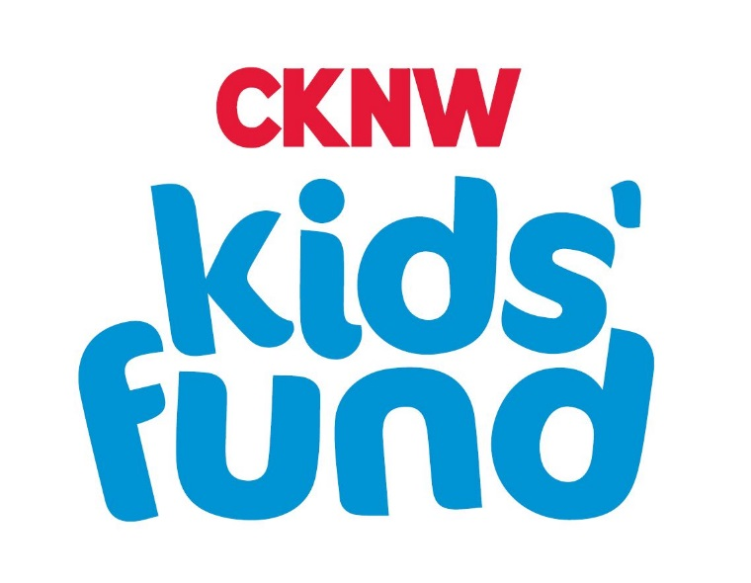

Requirements:

Organizations must provide:
  - A completed signed application form including reasons for funding
  - A list of Board members and their contact numbers
  - The history of the organization
  - A copy of the most current annual report with financial statements etc.
  - A complete project budget outlining the portion requested from the CKNW Kids’ Fund as per Appendix 1 (mandatory)
  - An organization should be able to prove that it is pursuing all possible avenues of financial support for their project.
  - Quotes are required for equipment.
  - Goods or services purchased must be for the specific purpose requested. Any other use may result in cancellation of the grant and denial of future grants.
  - GST should be included in the grant request.

Process:

  - Organizations will be advised of approval in writing.
  - Services/purchases or equipment etc., are not to be undertaken until a letter of approval is received.
  - Invoices are to be submitted to the CKNW Kids’ Fund by the expiry date noted in the letter of approval.
  - Organizations are required to provide an original invoice along with an itemized statement of expenses with supporting receipted invoices.
  - Upon receipt of an invoice, reimbursement will be made by the CKNW Kids’ Fund within a reasonable period of time.
  - All organizations in receipt of grants will be expected to provide follow-up reporting about the use of the funds and the effectiveness of the funded program.

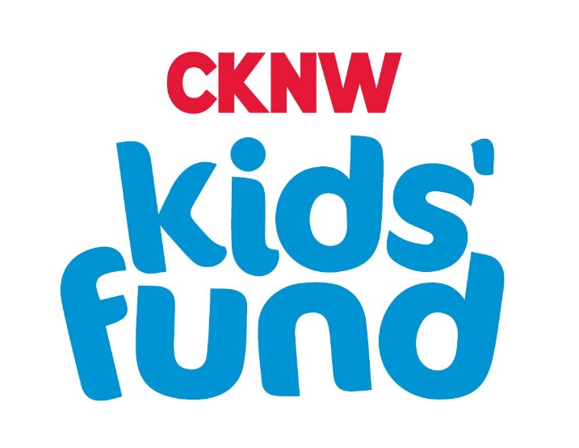

Equipment Ownership:

Equipment funded by the CKNW Kids’ Fund becomes the property of the organization for whom it was purchased. Where the equipment is no longer required, it is essential that the item(s) be made available to others with similar needs. HealthLinc Medical Equipment Mobility & Accessibility (HME) administers the Children’s Medical Equipment Distribution Service (CMEDS) which loans and recycles equipment for the Ministry of Children and Family Development’s Medical Benefits program.

General Exclusions:

In keeping with the mandate and guidelines of the CKNW Kids’ Fund, the following and similar organizations and projects will not typically receive funding:

- Buildings, playground construction
- Capital campaigns / (bricks & mortar)
- Construction, modifications
- Operation or administrative costs, including office equipment/computers
- Private/Public Day care centre fees
- Research projects/ conferences
- Salaries/administration/travel not directly benefiting children
- School Boards
- Start up costs for projects etc.

The Fund that Works for Challenged Children Twelve Months a Year

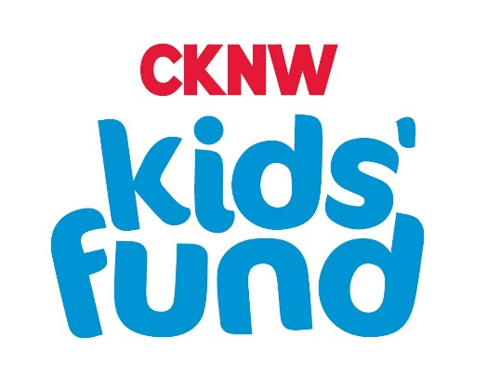

GRANT APPLICATION FOR ORGANIZATIONS

Please send your application on this form. Complete all sections. Any attachments necessary should be in 8-1/2” x 11” format.

Name:
B.C. Society Reg. #:
Fed. Registered Charity #:
Address:
City: _______________________________________Postal Code: ________________________
Phone Number: ( )
Email:
Executive Director/Manager:
A director may call for additional details.

ATTACHMENTS required

  - Appendix 1
  - a complete project budget outlining the portion requested from the CKNW Kids’ Fund as per Appendix 1
  - the history of the organization
  - a copy of the most recent annual report with financial statements
  - a list of Board members and their contact numbers

FINANCIAL INFORMATION
List your sources of funding and state all other funding resources you have approached for this project (sources, amount, funding confirmation).

How much did you receive through BC Gaming Branch licenses last year?

Have you applied and received a grant from the CKNW Kids' Fund in the past two years?

Are you associated with other nonprofits whose fund raising would benefit your organization? Identify them with contact numbers.

REQUEST

What amount is requested from the CKNW Kids’ Fund?
When would these funds be required?
What recognition can you offer the CKNW Kids' Fund?

PROJECT
Short Title:
Briefly describe the proposed project including the target population – ages, special needs, the program needs, and specific goals. Use another sheet if necessary.

The CKNW Kids’ Fund would like to share information to our donors about the programs and organizations we are supporting, to show where their donations are going in the community. We share this information through radio ads, mail, email, our website and social media channels. Would your organization be able to provide a short story and possibly video and pictures if this grant application is approved? Please explain.
_____________________________________________________________________________________
_____________________________________________________________________________________
_____________________________________________________________________________________

AUTHORIZED SIGNATURE OF ORGANIZATION:
TITLE: ____________________________________ DATE:

Contact number:____________________________________________________

Please MAIL application to:

Cathy Hunt – Director of Grants
CKNW Kids’ Fund
7850 Enterprise Street
Burnaby BC V5A 1V7

APPENDIX 1

ITEM EQUIPMENTS/SERVICES | QUANTITY | DESCRIPTION  (Size, make etc.) | REASON WHY NEEDED | SUPPLIER | COST

